**AVERAGE**

**Type 1: Relationship between average and numbers.**

1. The average of first 60 natural numbers?

**Soln:**

Sum of first and last number/2 =>(1+60)/2 = 30.5

1. Average of 10 positive numbers is x. If the numbers are increased by 20% then x is increased by.

**Soln:**

When all the values in a series is increased by 20% then the average will also get increased by 20%

1. Eight consecutive numbers are given. If the average of two numbers appear in the middle is 6, then the sum of 8 given numbers is ?

**Soln:**

Let's eight sequentially number are x, x+1, x+2, x+3, x+4, x+5, x+6 and x+7.  
According to the question, ( x+3+x+4)2 = 6  
=> (2x+7)/2 = 6 = 2x + 7 = 12 => x = 5/2  
Therefore, Sum of all eight numbers

= x+x+1+x+2+x+3+x+4 +x+5+x+6+x+7=8x+28  
=8 X 5/2+ 28 = 20 + 28 = 48

1. The average of four positive integers is 73.5. The highest integer is 108 and the lowest integer is 29. The difference between the remaining two integers is 15. Which of the following is the bigger of the remaining two integers?

**Soln:**

Sum of four integers = 73.5 × 4 = 294

Sum of two middle integers = 294 – (108 + 29) = 157

Difference between two integers = 15

The smallest number = (157 – 15) / 2 = 71

**Type 2: Questions based on partial averages and overall average**

1. The average of 11 results is 50. The average of first 6 is 49 and that of last 6 is 52, find the sixth result

**Soln:**

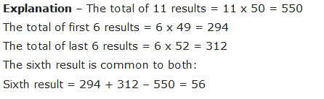

1. The average mark scored by 120 candidates in an exam is 35. If the average mark of passed candidate is 39 and that of failed candidate is 15. What is the number of candidates who passed the exam?

**Soln:**

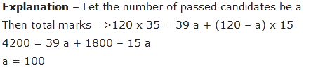

1. The average age of students of a class is 15.8 years the average age of boys in the class is 16.4 years and that of girls is 15.4 years. The ratio of the number of boys to the number of girls in the class is?

**Soln:**

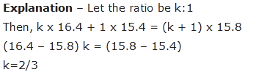or 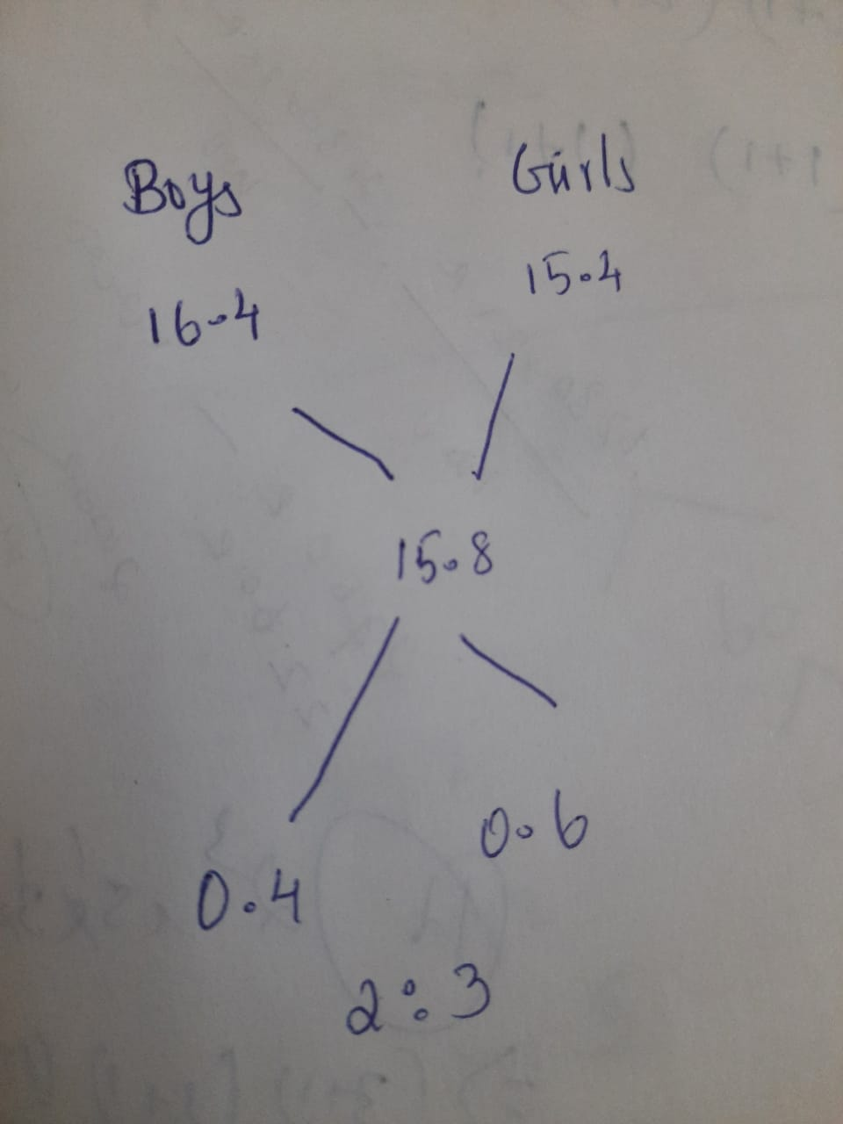

1. The average of six numbers is 3.95. The average of two of them Is 3.4, while the average of other two is 3.85. What is the average of remaining two numbers?

**Soln:**

If the average of all six numbers is 3.95, then the total of all six is 23.7 (6×3.95). The average of two of them is 3.4, so the total for those two numbers is 6.8 (3.4×2).

 The average of the other two is 3.85, so the total for those two is 7.7 (3.85×2).

To find the average of the remaining two, first find what their sum would equal.

7.7+6.8+x=23.7

1. The average age of boys in a class is 16 years and that of the girls is 15 years. The average age of the whole class is?

**Soln:**

As number of girls and boys is not given so result can’t be computed

1. The arithmetic mean of the scores of group of students in a test was 52. The brightest 20% of them secured a mean score of 80 and the dullest 25% a mean score of 31. The mean score of remaining 55% is?

**Soln:**

Let the required means score be x. Then,  
20 * 80 + 25 * 31 + 55 * x = 52 * 100  
= 1600 + 775 + 55x = 5200  
= 55x = 2825  
= x = 565/11 = 51.4.

1. The average mark in two subjects is 35 and three other subjects are 40. Then find the average mark in all five subjects?

**Soln:**

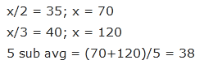

1. If a man spends 1000rs for the first five months, 2000rs for next four months and 3000rsfor next three months and he saves 2000rs in the whole year then his average monthly salary will be?

**Soln:**



1. The average salary of 120 employees in a bank is Rs.15, 000 per month. If the number of clerk is thrice the number of managers and the average salary of clerk is 1/3rd of the average salary of managers. Find the average salary of managers?

**Soln:**

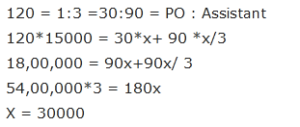

1. The average salary of entire staff in an office id Rs.250 per month. The average salary of officers is Rs. 520 and that of non-officers is Rs.200. If the number of officers is 15, then the number of non-officers in the office is ?

**Soln:**

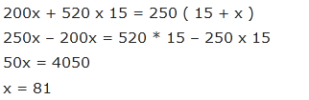

1. In a famous hotel the rooms were numbered from201 to 230, each room gives an earning of Rs.5000 for the first fifteen days of a month and for the latter half, Rs. 3000 per room. Find the average income per room per day over the month September.

**Soln:**

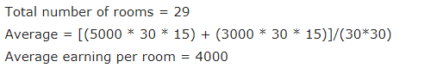

1. In a famous hotel the rooms are numbered from 101 to 130on the first floor, 201 to 220 on the second floor and 301 to 330on the third floor. In the month of November, the room occupancy was 50% on the first floor, 80% on the second floor and 40% on the third floor. If it is also known that the room charges areRs.200, Rs.250 and Rs.300on each of the floors respectively, then find the average income per room in the hotel for month of November?

**Soln:**

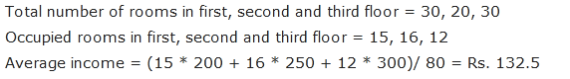

1. Average age of 30 students in a class is 20 years and out of it average age of 25 students is 15. What is the average age of remaining students?

**Soln:**

Total age of all students = 30 * 20 = 600

Age of 25 students = 25 * 15 = 375

Difference = 600 – 375 = 225

Therefore, average age of remaining = 225/5 = 45

1. The average temperature for the first five days of the month is 40’c and the average temperature from second to sixth day is 42’cand the ratio between the temperature of first and sixth day is 3 : 4. Find the temperature on the sixth day?

**Soln:**

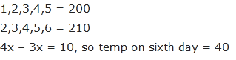

1. The average salary of all the workers in a factory is Rs.7000. the average salary of 9 mechanic is Rs.5000and for the rest of the workers it is Rs.4000. Find the total number of workers in the factory?

**Soln:**



**Type 3: Questions based on age**

1. The average age of a couple at the time of marriage was 20 years. After 8 years they have a kid of 4 years old. Find the average age of the family when the baby was born?

**Soln:**

During the time of marriage the age of husband and wife is 20 * 2 = 40

At the time of birth of child i.e. 4 years later age = 40 + 4 + 4 =48

Therefore, the average = 48/3 = 16

1. The average age of 5 children of a family is 10 years but if we include the age of father and mother then the average age becomes 22 years. It is given that father’s age is 6 years more than the mother then what will be the age of mother at present?

**Soln:**

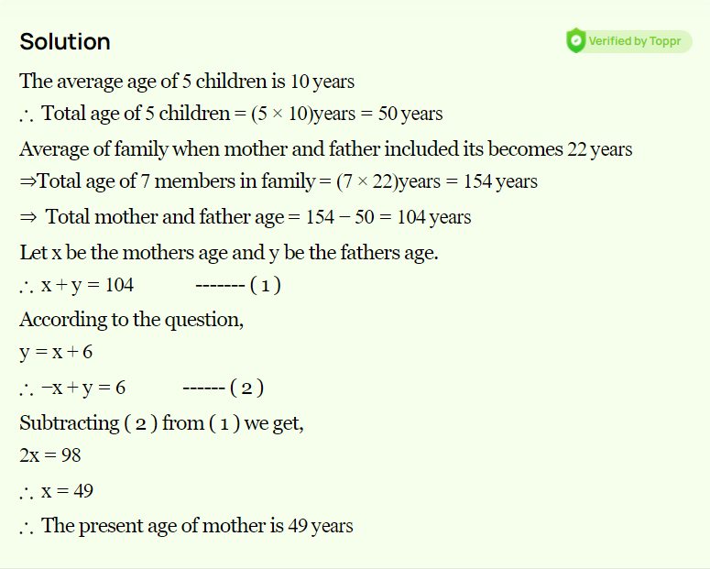

1. The average age of a husband and is wife was 25 when they were married 7 years ago. Now the average age of husband wife and his son is 23 years. Find the age of son now?

**Soln:**

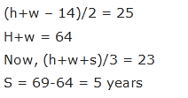

1. The average age of a family of 8 members is 24 years. If the age of youngest member is 6 years, the average age of family at the birth of the youngest member was

**Soln:**

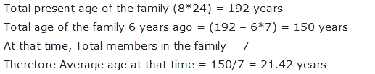

1. The ages of 4 members in a family are in the year are ‘x’, ‘x + 12’, ‘x + 24’ and ‘x+36’. After some years oldest among them was dead then average reduced by 3.After how many years from his death, the average will be as same as 2010?

**Soln:**

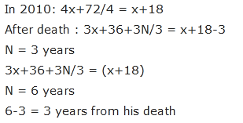

**Type 5: Questions based on replacement and without replacement**

1. The average weight of 12 people gets increased by 3.5 Kg when a person weighs 56 kg got replaced by another man. Find the weight of new man?

**Soln:**



Short cut: new man = changed weight ± no of person * change in average

New person = 56 + 12*3.5 = 98

1. The average weight of 40 balls is 5 grams. When the weight of the basket is added to the weight of the balls the average increased by 0.5 grams. Find the weight of the basket?

**Soln:**

New weight = 40 * 0.5 + 4.5 = 24.5

1. There are fifty students in hostel. Now the number of students got increased by 8. Due to this expenses of mess increased by 30 rupees per day while the average expenditure decreased by 2 rupees. Find the initial expenditure?

**Soln:**

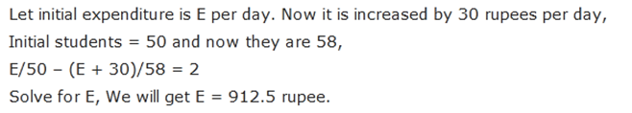

1. The average age of 30 students is 16 years. If the age of teacher is also included then the average age increased by 1 year, find the age of the teacher?

**Soln:**

**Age of teacher =** 16 + 31*1 = 47

1. The average age of a class of 20 students is 12 years. Out of which one student whose age is 10 years left the class and two new boys entered the class . the average of the number remains the same and the difference between the ages of new boys is 4 years. What will be the age of younger one?

**Soln:**



1. In a group of 8 boys, 2 boys aged 21 and 23 are replaced by 2 new boys. Due to this the average age of the boy increased by 2 years. What is the average age of 2 new boys?

**Soln:**

Average of 8 boys increased by 2, this means the total age of boys increased by 8*2 = 16 yrs

So sum of ages of two new boys = 21+23+16 = 60

Average of these = 60/2

1. The average age of the group having 3 members is 84. One more person joins the group and now the average becomes 80. Now a fifth person comes whose age is 3 years more than that of the fourth person replaces the first person. After this the average age of the group becomes 79. What is the weight of the first person?

**Soln:**

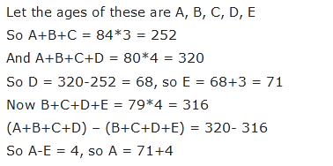

1. The average age of 15 army men is 60 years. 5 new army men of average age 30 yeas join them. Find the new average age?

**Soln:**

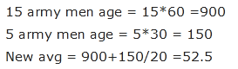

1. The average weight of 40 students is32. If the heaviest and the lightest are excluded the average weight reduces by 1. If only the heaviest is excluded then the average is 31. Then what is the weight of the lightest?

**Soln:**

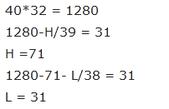

1. In English exam, the average of class ‘A’ was found to be ‘x’ marks. After detucting a computational error, the average marks of 100 candidates got reduced from 74 to 54. The average thus came down by 25 marks. The total number of candidates who took the English exam was?

**Soln:**



**Type 6: Questions based on mistaken values**

1. The average height of 15 students was calculated as 75. But later it was found that the height of 1 student wrongly entered as 35 instead of 38 and another as 46instead of 63. The correct average is?

**Soln:**

Avg = 75 + ((38-35 + 63 – 46)/15) = 76.33

1. A pupil's marks were wrongly entered as 83 instead of 63. Due to that the average marks for the class got increased by half (1/2). The number of pupils in the class is:

**Soln:**

Let there be *x* pupils in the class.

| Total increase in marks = | https://www.indiabix.com/_files/images/aptitude/1-sym-oparen-h1.gif | *x* * | 1 | https://www.indiabix.com/_files/images/aptitude/1-sym-cparen-h1.gif | = | *x* |
| --- | --- | --- | --- | --- | --- | --- |
| 2 | 2 |

| https://www.indiabix.com/_files/images/aptitude/1-sym-tfr.gif | *x* | = (83 - 63)   https://www.indiabix.com/_files/images/aptitude/1-sym-imp.gif | *x* | = 20    https://www.indiabix.com/_files/images/aptitude/1-sym-imp.gif  *x*= 40 |
| --- | --- | --- | --- | --- |
|  |  |

1. The average age of 40 students in a class is 75 kg. By mistake the weights of two students were read as 74 kg and 66 kg respectively instead of 66 kg and 54 kg respectively. Find the corrected average of the class?

**Soln:**

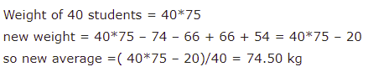

### The Average Mark Of Aakash In 5 Subjects Is 89,And It Is Noted Finally That Science Mark Is Wrongly Written As 90 Instead Of 95 Then Find The Average Mark Of Aakash?

**Soln:**

Mark in 5 subjects = 89 * 5 = 445

New total = 445 + 5 =450

So, new average = 450 / 5 = 90

**Type 7: Questions based on cricket**

1. A cricketer has completed 10 innings and his average is 21.5 runs. How many runs must he take in next innings so as to raise his average by 24?

**Soln:**

total run scored in 10 innings = 21.5×10= 215

total run he must score after 11 innings= 24×11= 264.

he must score in 11th Innings= 264-215= 49.

Short cut : runs = 21.5 + 11* 2.5 = 21.5 + 27.5 = 49

1. A batsman in his 17th innings makes a score of 85, and thereby increases his average by 3. What is his average after 17 innings?

**Soln:**

Let x be the average till 16th innings

16x + 85 = 17(x + 3)

x = 34 + 3 = 37

short cut: avg = 85 – 16*3 = 85 – 48 = 37

1. Dhoni scores 8000 runs in a certain number of innings. In next five innings he was out of form and hence, could make only 85 runs as a result his average reduced by 1 run. How many innings did he play in total?

**Soln:**

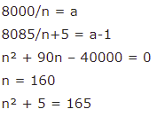

1. A cricketer has an average of 55 after playing 20 matches. How many runs should he score in the next match so as to increase the average to 57?

**Soln:**

Runs till 20th match = 55 * 20 = 1100

Let the runs made in next inning be x.  
(1100+x)÷21=57  
1100+x=1197  
x=97

1. A cricketer whose bowling average is 12.4 runs per wicket takes 5 wickets for 26 runs and thereby decreases his average by 0.4. The number of wickets taken by him till the last match was.

**Soln:**

Let He has taken X wickets before the match.

And runs given with the average 12.4, So total run given was,

= 12.4X  
Runs given including this match,

12.4X +26 with the average of 12.

Now,  
(12.4X+26)/(X+5) = 12  
12.4X + 26 = 12X + 60  
0.4X = 34  
X = 85 wickets

**Type 8: Miscellaneous**

1. The average of 20 numbers is 0. Of them, at the most, how many may be greater than 0.

**Soln:**

Average of 20 numbers = 0.

Therefore Sum of 20 numbers = (0 x 20) = 0

It is quite possible that 19 of these numbers may be positive and if their sum is a, then 20th number is (-a).

1. In Jessica's opinion, her weight is greater than 65 kg but less than 72 kg. Her brother doesn’t agree with Jessica and he thinks that Jessica's weight is greater than 60 kg but less than 70 kg. Her mother's view is that her weight cannot be greater than 68 kg. If all are them are correct in their estimation, what is the average of different probable weights of Jessica?

**Soln:**

Let Jessica's weight by X kg.

According to Jessica, 65 < X < 72

According to Jessica's brother, 60 < X < 70.

According to Jessica's mother-, X <= 68

The values satisfying all the above conditions are 66, 67 and 68

1. A student was asked to find the arithmetic mean of the numbers 3, 11, 7, 9, 15, 13, 8, 19, 17, 21, 14 and x. He found the mean to be 12. What should be the number in place of x ?

**Soln:**

Total = 12 *12 = 144

Sum of given 11 numbers = 137

Difference = 144 – 137 = 7

1. A library has an average of 510 visitors on Sundays and 240 on other days. The average number of visitors per day in a month of 30 days beginning with a Sunday is :

**Soln:**

 Since the month begins with a Sunday, so there will be five Sundays in the month,

Required average = (510 * 5 + 240 * 25) / 30 = 8550/30 = 285.

1. There were 35 employees in the start-up company. If the number of employees increases by 7,the expense send for Refreshment increases by Rs.42 per day while the average expenditure per head diminishes by Rs.1.Find the Original expenditure for the Refreshment?

**Soln:**

Let us Assume Average Expenditure be X initially

Therefore, the total Expenditure =35X

When 7 more Employees join the Company, total expenditure =35x+42(Given in the Question)

After this the expenditure decreases by Rs.1 for each employee

(35X+42)/(35+7)=X-1

7X=84 => X=12

Thus,the original expenditure for refreshment=35*12=Rs.420

1. The sum of three numbers is 98. If the ratio between first and second be 2 : 3 and that between second and third be 5 : 8, then the second number is?

**Soln:**

Let the three parts be A, B, C. Then,

| A : B = 2 : 3 and B : C = 5 : 8 = | https://www.indiabix.com/_files/images/aptitude/1-sym-oparen-h1.gif | 5 x | 3 | https://www.indiabix.com/_files/images/aptitude/1-sym-cparen-h1.gif | : | https://www.indiabix.com/_files/images/aptitude/1-sym-oparen-h1.gif | 8 x | 3 | https://www.indiabix.com/_files/images/aptitude/1-sym-cparen-h1.gif | = 3 : | 24 |
| --- | --- | --- | --- | --- | --- | --- | --- | --- | --- | --- | --- |
| 5 | 5 | 5 |

| https://www.indiabix.com/_files/images/aptitude/1-sym-imp.gif A : B : C = 2 : 3 : | 24 | = 10 : 15 : 24 |
| --- | --- | --- |
| 5 |

| https://www.indiabix.com/_files/images/aptitude/1-sym-imp.gif B = | https://www.indiabix.com/_files/images/aptitude/1-sym-oparen-h1.gif | 98 x | 15 | https://www.indiabix.com/_files/images/aptitude/1-sym-cparen-h1.gif | = 30. |
| --- | --- | --- | --- | --- | --- |
| 49 |